If you have any questions, please call the Bookstore ask for :
Julie Poulas: 608-4160 or Lynn Doulas: 608-4164
E-mail: textbooks@morainevalley.edu
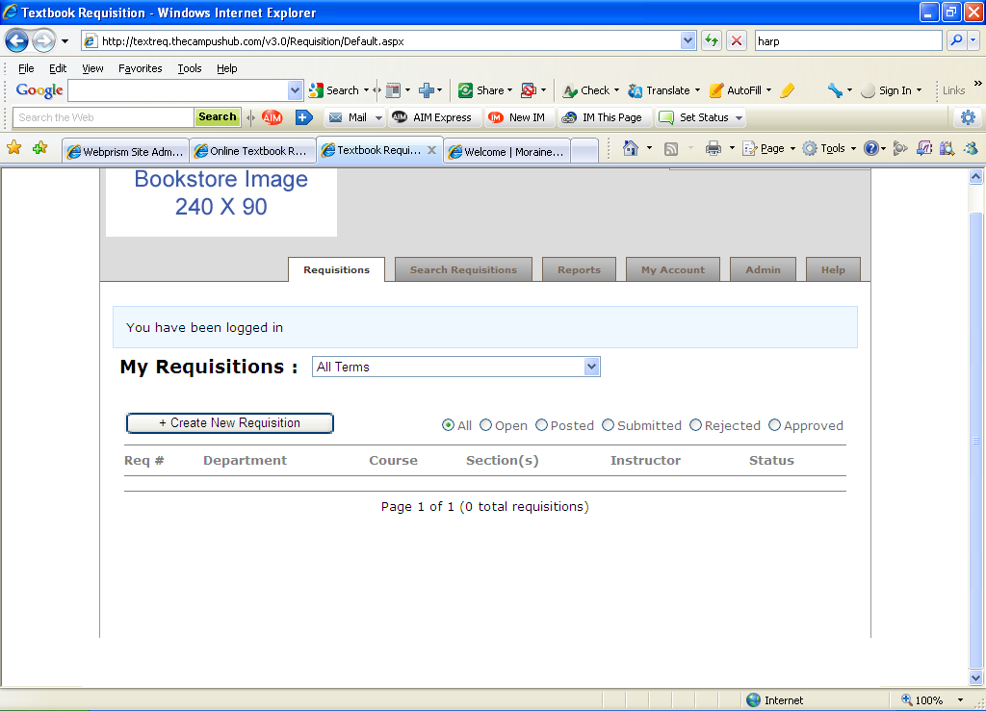
1
2
3
Click on Requisition tab
Choose semester with drop-down box
Click on Create New Requisition

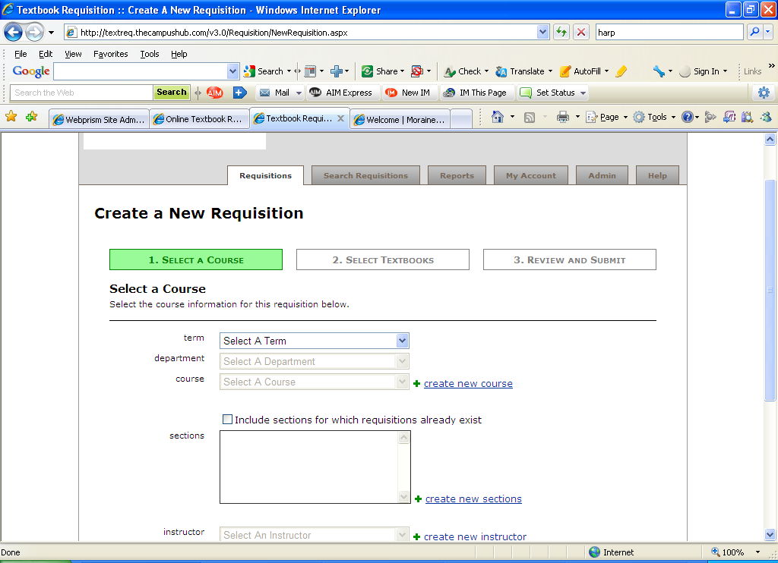
4
Choose Semester, Department and Course with drop-down box
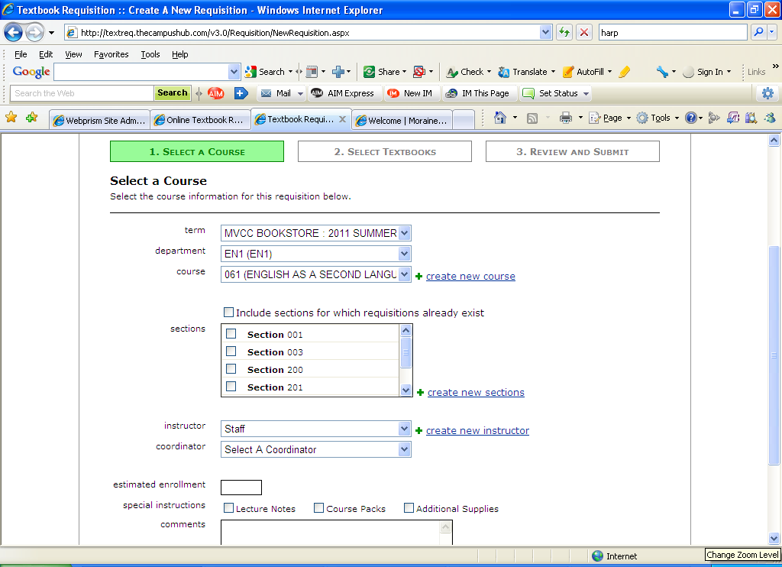
5
6
Select a section
Hit to create a new section if additional sections are needed or a section is not listed
Reminder: Please notify Bookstore Textbook Department if additional sections are added or changed
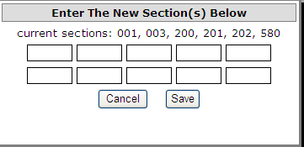
6a
Enter sections needed
7
Select Instructor and select Coordinator (which will be Dean)
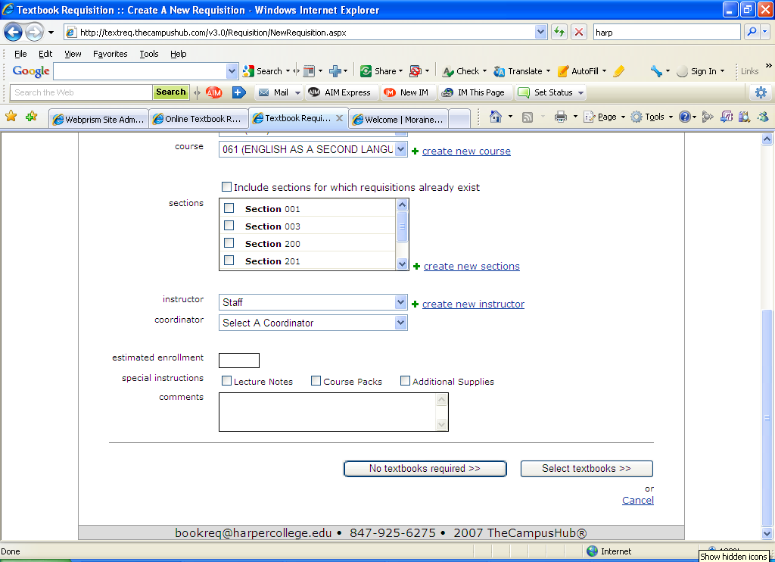
8
9
Please enter estimated enrollment and special instructions if any
If no textbook is required please click here

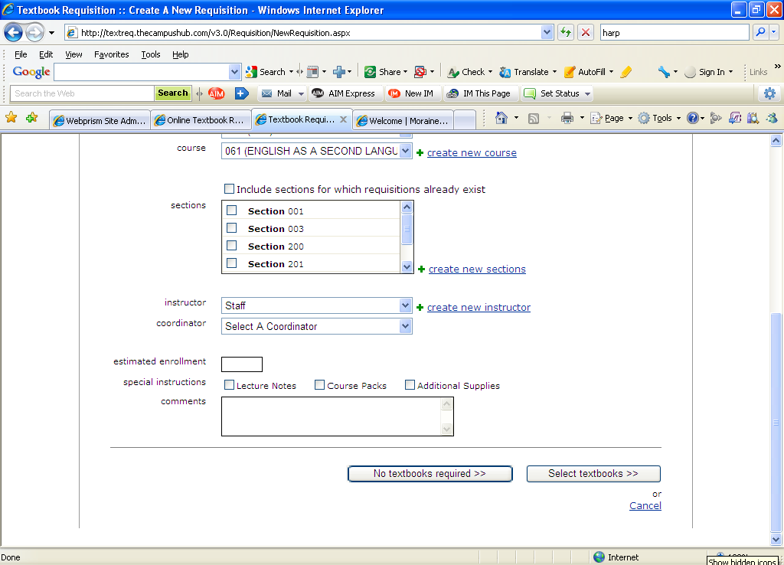
10
Click Select Textbooks if books are either required or optional

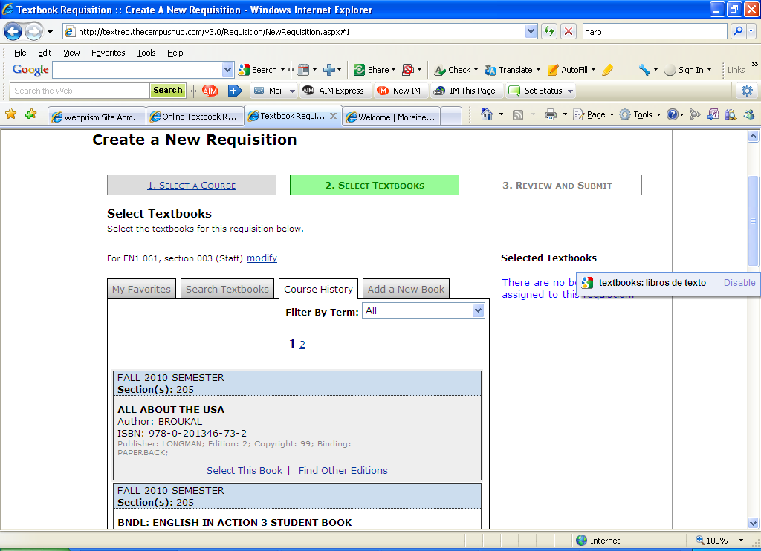
11
11a
Click on Course History tab to view a list of previously selected textbooks.
Click on “Find Other Editions” to get the new edition information.
EX: ISBN #, Copyright, Edition
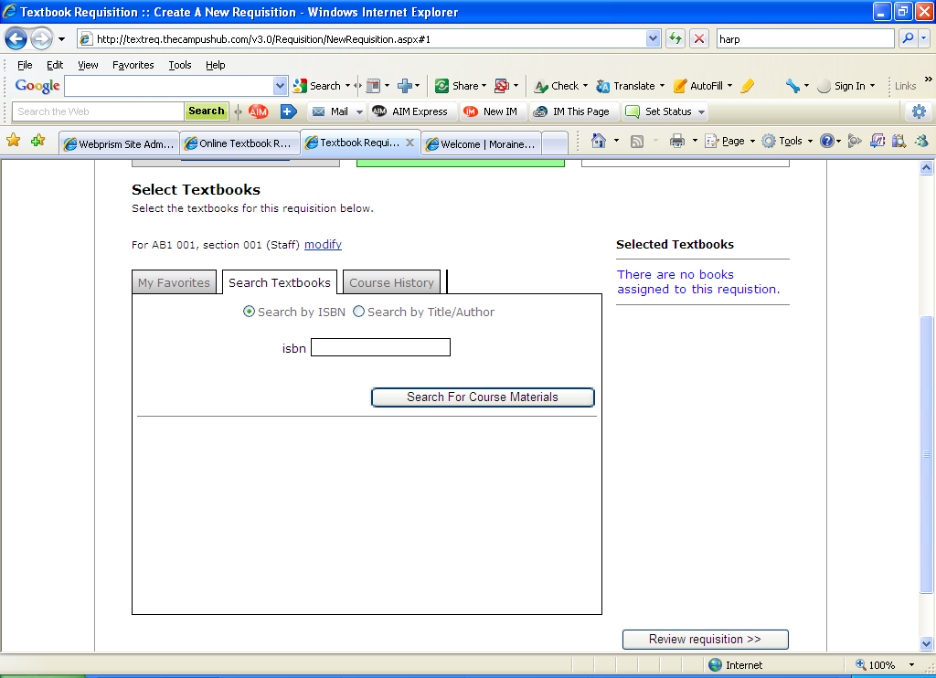
12
If text book being selected is NOT listed, please enter ISBN number under Search Textbook tab and click Search for Course Materials
13
If selecting textbook from list click on Select This Book.
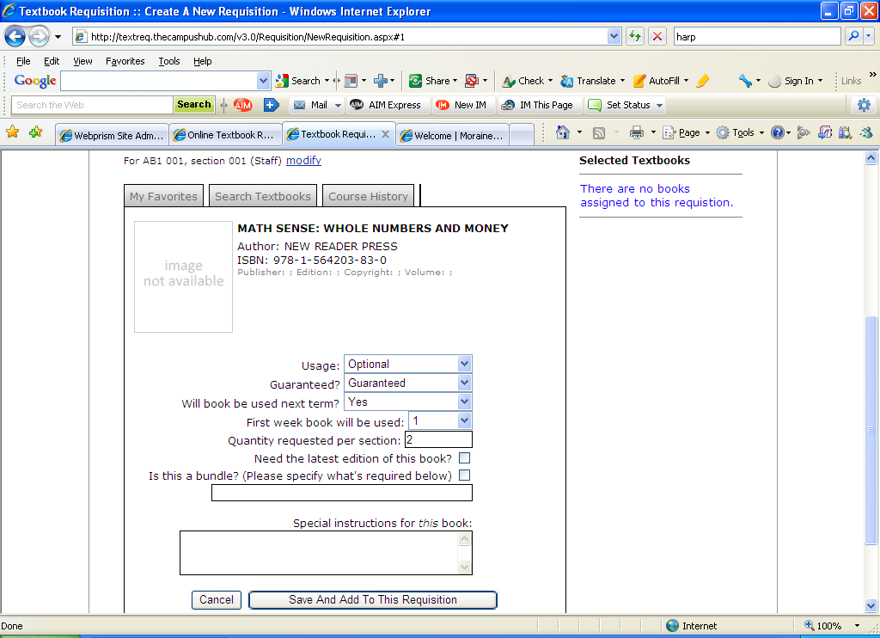
13a
13b
If New edition is requested please indicate the edition in the special instruction box
Click on Save and Add to this Requisition
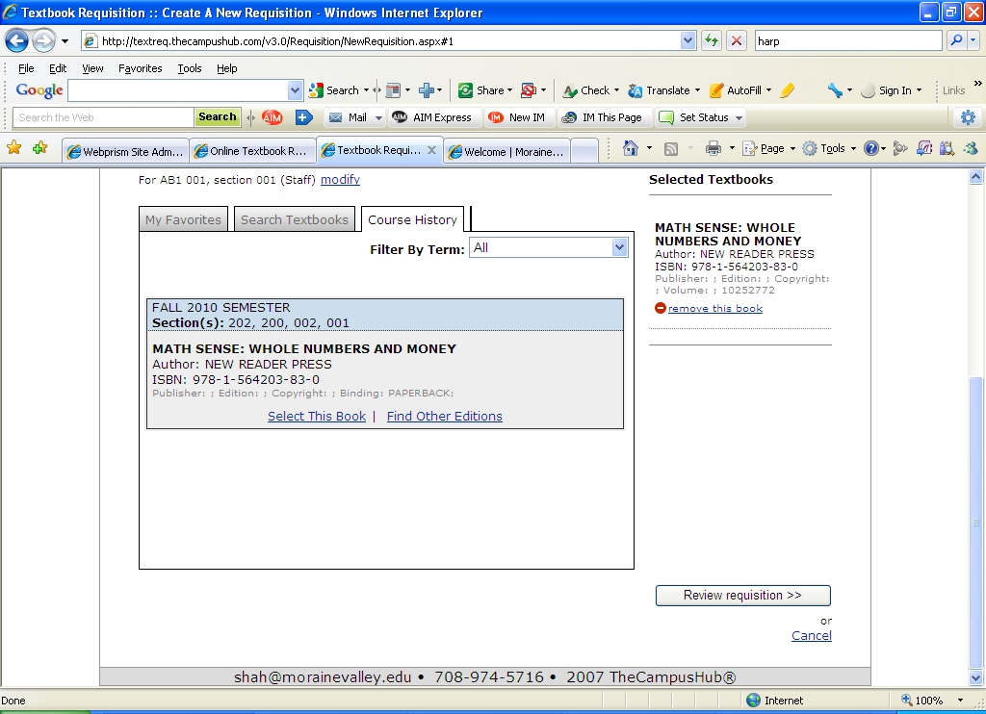
14
Click on Review Requisition
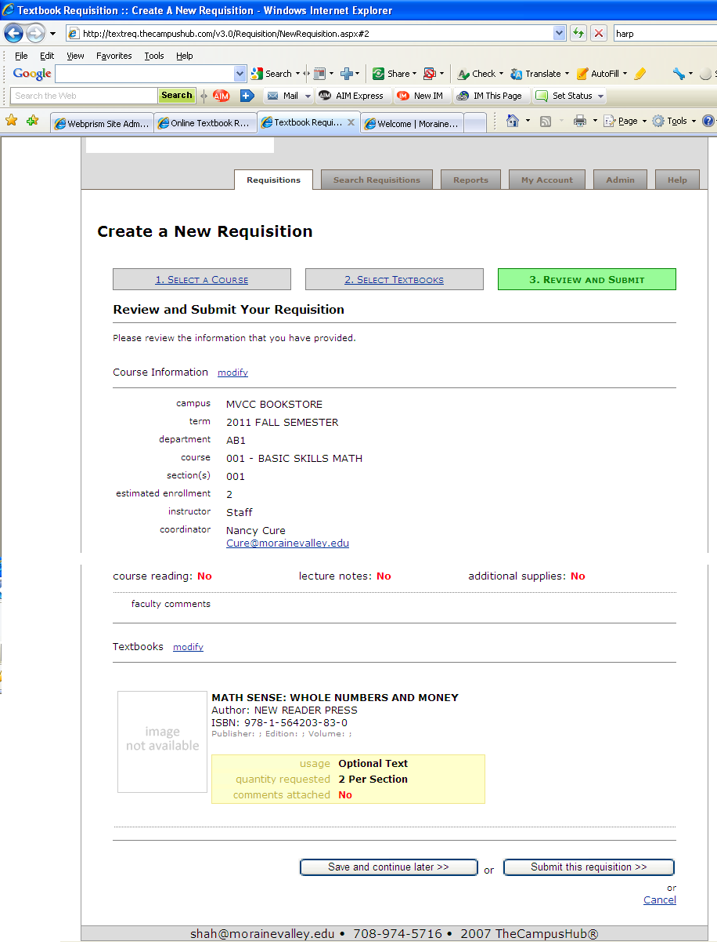
15
15a
16
16a
All textbooks selected will appear here.
If changes need to be made to Course Information click on Modify (Repeat steps 4-10) change information, save and add and review requisition
If changes need to be made to Textbooks click on Modify (Repeat steps 11-13b) change information, save and add and review requisition
Choosing Submit this Requisition will forward textbook request to designated approver
Instructors: When you have finished making your textbook selections click Save and continue later. This will place textbook requisition in a pending state until submitted
*Once requisition is approved an email is received in the Bookstore

